



**Amirkabir University of Technology**

**(Tehran Polytechnic)**

**2021-2022**

Modern control project Report

**Nonlinear Control of**

**the Inverted Pendulum**

**Melika Salehian**

**Mahban Gholi Jafari**

**Fatemeh Karar**

**Maryam Heydari**

**Professor: Dr Atrianfar**

Autumn and winter 1400

**Phase 1**

In the first phase of the project, we model the system and evaluate the stability, controllability and visibility features of the system.

**1- Introduction of the generalities of physical system and examples of industrial applications**

A cart inverted pendulum system has been served as a general model for robotic systems. The cart pendulum system is a non-linear, under-actuated system with unstable zero dynamics and must be controlled such that the position is at its unstable equilibrium. it is clear that the inverted pendulum is a system with many variations that render it a fundamental control problem. Apart from its variations, its analysis and control can be studied using a plethora of different techniques. The system can be controlled using various optimization techniques. Predictive control techniques can be applied, which aim at determining a series of future control actions that will balance the system. Adaptive control techniques can also be used. Such methods are useful when certain parameters of the system change during its simulation. Such methods are used for example when the cart goes through a different terrain and the friction coefficient changes or when an object is suddenly placed on the end of the rod, changing its center of gravity. Overall, the inverted pendulum is a system that helps engineers test the efficacy of new control methods and for that matter it works as a bridge between theoretical approaches and their application to real life problems. A cart inverted pendulum system has been served as a general model for robotic systems. Another example is driving a car, where the control is applied through the driver who is the one affecting the system’s inputs, which are the speed and direction, aiming for a safe drive. Also, in every industrial facility each part of the production line functions under the supervision of digital controllers that ensure that each engine works properly according to specific control and design specifications.

**2. Nonlinear system model and its parameters**

The cart pendulum system is a non-linear, under-actuated system with unstable zero dynamics and must be controlled such that the position is at its unstable equilibrium.

A cart inverted pendulum system has been served as a general model for robotic systems. The cart pendulum system is a non-linear, under-actuated system with unstable zero dynamics and must be controlled such that the position is at its unstable equilibrium.

linearized equations of the pendulum (where the mass is concentrated at the top) are studied in the form of:

Equation - state space form

If matrices A and B form a controllable pair, then the local optimal feedback control u is given by:

Equation

where P satisfies the algebraic Riccati equation and R is a weighting matrix. the global pendulum model in the form of

Equation

and the corresponding controllability of (A(x), B(x)) for almost all x (i.e. controllable, apart possibly from a set of measure zero) are analyzed. The x in A(x) and B(x) is fixed for each step, therefore the nonlinear model resembles the linear case for one step. This method also demonstrates effective robust control because of the update at each step, so any inaccuracy of A and B is adjusted automatically. Furthermore, the global control u is shown to be

Equation

where P(x) satisfies the pointwise algebraic Riccati equation:

Equation

where Q and R are weighting matrices. It is shown that the single pendulum installed on a cart can be controlled from a large range of initial positions, including the rest position where the pendulum hangs downwards. The double-link pendulum and car system can also be controlled from many initial positions.

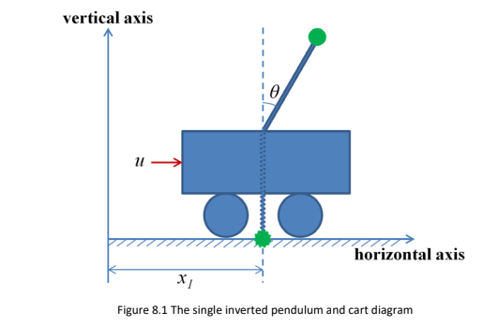**Modelling of the Cart-Pendulum Systems**

Figure 1- the single inverted pendulum and cart diagram

Often inverted pendulums are considered in combination with moving carts. The system of a single pendulum installed on a cart is drawn in Figure 1.

The dynamical model of the cart and the pendulum are equations of motions often obtained by applying force analysis using free body diagrams and Newton's second law F = ma. However, there are other methods available for achieving a system’s dynamical model; for example, the Lagrangian approach which calculates the difference between total kinetic energy T and the total potential energy V of the system:

Equation

and the Hamiltonian equation which calculates the sum of the two types of energy:

Equation

It is usually easier to use the Lagrangian method than the one based on force analysis because all is required are the generalized kinetic and potential energy terms, so resolving of the forces (which is often complicated) is not needed. We adopt the Lagrangian approach for its simplicity, where the Lagrange's equations are given by:

Equation

where 𝑥𝑖 represents the ith generalized coordinate and f𝑖𝑖 the ith generalized force applied on the object. These Lagrange's equations are equivalent to Newton's laws.

In the case of a single pendulum-cart system, there are two x variables shown in Figure 2.1, namely the horizontal distance 𝑥1 (m) travelled by cart from the left reference, and the angle 𝜃 (rad) between the pendulum rod and the vertical axis. 𝑥̇ 1 and 𝜃̇ represent velocity of the cart along the horizontal axis and angular velocity of the rod around the rod-cart connection point, respectively. Here,

Equation

The total kinetic energy of the pendulum-cart system can be written as:

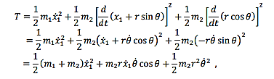

Equation

where 𝑚1 and 𝑚2 are the masses of cart and of pendulum respectively, r denotes the length of the pendulum and g is acceleration due to gravity. The total potential energy of the system, using the bottom of the pendulum rest position as the vertical reference point, can be written as:

Equation

Therefore, the Lagrangian equation is given by



Equation

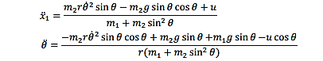

Equation

which satisfies Newtown's second Law automatically. Note the two equations in above both have 2nd derivatives on the left-hand-side and are not yet in the standard state space model form. A state- space representation of the system can be written as

~~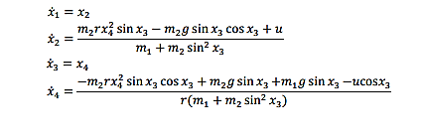~~

Equation ~~14~~

by introducing three new variables, 𝑥2, 𝑥3 & 𝑥4, i.e. 𝑥2 = 𝑥̇ 1, 𝑥3 = 𝜃 & 𝑥4 = 𝑥̇ 3 and splitting each of the equations into two equations. This translates into the state-space matrix form as:

~~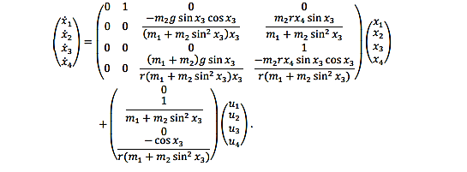~~

Equation

One particular advantage of this method is that it can be easily extended to a general multi-link pendulum case, without the need to perform complex force analysis on the new and previous pendulum objects. For example, a double pendulum and cart system is illustrated in Figure 2.2, where 𝜃1 and 𝜃2 represent the angles between the 1st and the 2nd pendulum rods and the vertical axis.

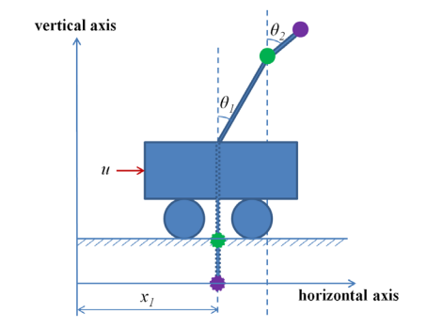

Figure - the double-link inverted pendulum and cart diagram

A similar energy analysis can be performed as before. Using the new vertical and horizontal references as indicated in Figure 2.2, the total kinetic energy and potential energy of the new system can be modified to

A similar energy analysis can be performed as before. Using the new vertical and horizontal references as indicated in Figure 2.2, the total kinetic energy and potential energy of the new system can be modified to:

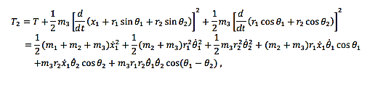

Equation 16

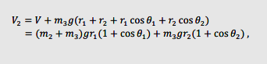

Equation 17

Which then leads to

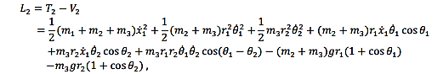

Equation

where 𝑚3 denotes the mass of the newly added pendulum, and 𝑟1 and 𝑟2 are the lengths of the original rod and the new rod respectively. The energy equations appear complicated; however, the analysis performed above is relatively straightforward in the sense that effect only comes from the new pendulum and corresponding energy terms can simply be added to the original equations. The process of obtaining a state-space model for the double-link pendulum cart system is also similar as the one is the single pendulum case. By solving the Langrage's equation and splitting each differential equation with a 2nd derivative into two equations containing only 1st derivatives (i.e. let 𝑥2 = 𝑥̇ 1, 𝑥3 = 𝜃1, 𝑥4 = 𝑥̇ 3, 𝑥5 = 𝜃2 and 𝑥6 = 𝑥̇ 5), we obtain standard state space model of the double-link pendulum cart system in matrix form:

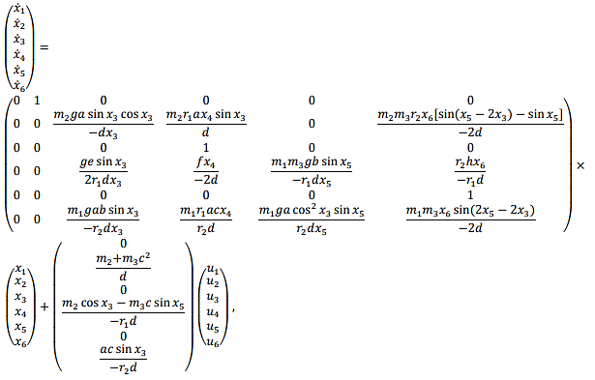

Equation

Where 𝑎, 𝑏, 𝑐, 𝑑, e , 𝑓, and ℎ have been defined as the following:

𝑎 = 𝑚2+𝑚3

𝑏 = cos 𝑥3 cos 𝑥5

𝑐 = sin (𝑥3 − 𝑥5)

𝑑 = 𝑚2𝑎 sin2 𝑥3 + 𝑚1𝑚3𝑐2 + 𝑚1𝑚2

𝑒 = 2𝑚2 2 + 𝑚1𝑚3 + 2𝑚2𝑚3 + 2𝑚1𝑚2 + 𝑚1𝑚3 cos(2𝑥5);

𝑓 = 𝑚2𝑎 sin(2𝑥3) – 𝑚1𝑚3 sin (2𝑥5 − 2𝑥3);

ℎ = 𝑚2𝑚3 sin 𝑥3 (cos 𝑥5) + 𝑚1𝑚3𝑐

**3- Linearization**

We used Lagrangian method to determine the dynamic model of the system which is given in the previous section. Now it is time to linearize the system. The general state space model of the system is

Equation

where x , is the state variable, u is the control vector and (A ,B are controllable parameters. By quadratic infinite-time cost function, the linear optimal feedback control solution is:

Equation

By implementing the above equation in the state space model we will have:



Equation

This equation is stable controlled system.

𝑹 is a weighting matrix and 𝑷 is a positive-definite Hermitian

To linearize the system we have to define a quiescent point. In the case of two inverted pendulum and cart system the quiescent point is when the inverted pendulums are kept in a small neighborhood of the vertical upright position. Therefore, x3, x4 x5, and x6 are small. Thus:

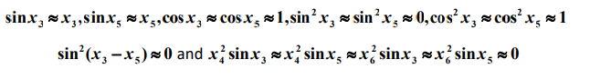

Equation

Then the linearized state-space model can be simplified as:

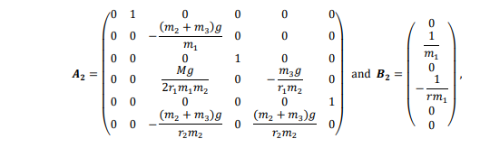

Equation 24

And M=2𝑚2 2 + 𝑚1𝑚3 + 2𝑚2𝑚3 + 2𝑚1𝑚2 + 𝑚1𝑚3

The linear models represent the systems adequately when the starting positions of the inverted pendulums are near the vertical upright positions. Because the linear optimal feedback controlled systems are stable at the equilibriums where 𝒙 = 0, the linear representations of the systems will always be valid as long as the initial positions are within a small neighborhood of the vertical upright position

**4-Jordan block and diagonal form**

First we obtained the state space form of the system by the use of ss function in Matlab. With state space variable the transfer function matrix can be derived. For the Jordan normal form we used Jordan function in Matlab and the result are shown below.

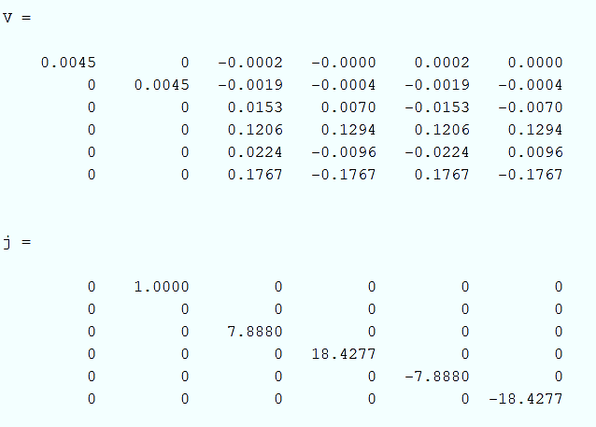

Figure

The transfer function matrix is:



With the Jordan normal form, new state space variables are obtained.

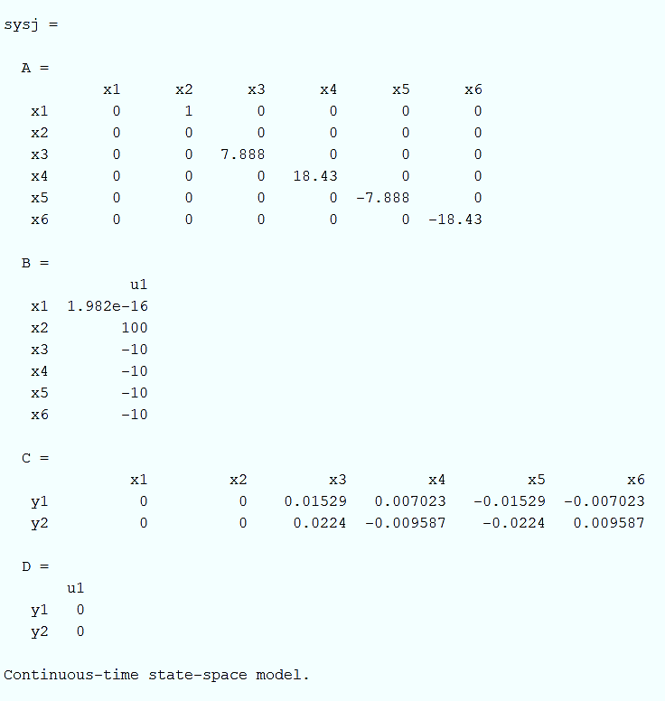

Figure -state space form

**5-transform function**

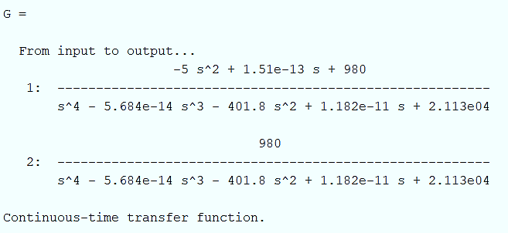

Figure 5

The pole zero map is as the figure 6.

|  |
| --- |
| Poles = 18.4277, -18.4277, 7.888, -7.888 and No zero |

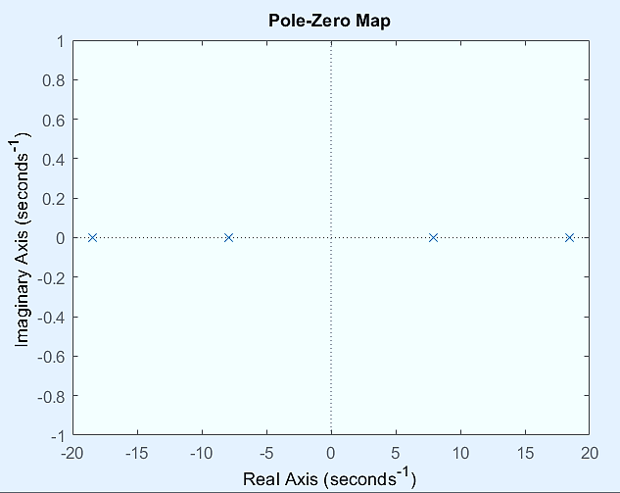

Figure 6- pole-zero map

**6- stability**

Inner stability will divide into two part:

1-Stability in the sense of Lyapunov : it's to be said if we have

Then if the eigenvalue of A has a none positive value which includes (0 and negative value) the stability will be stable in the sense of Lyapunov.

2- Asymptotically stability:

If the eigenvalue of A is strictly negative it will be stable in an as asymptotically way

With the Jordan form obtained in Part 4, we have the eigenvalues on the main diameter:

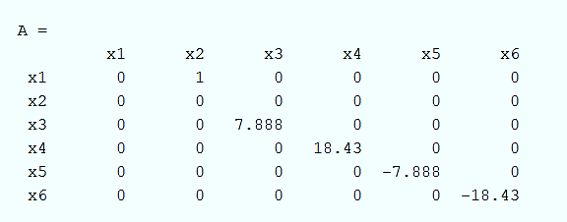

Figure 7

And also we obtained the eigenvalues by (command eig(A)) :

Eigen value : 0, 0, -18.4277, -7.888, 18.4277, 7.888

Lyapunov Stability: The real parts of eigenvalues are negative or zero, provided that the zeros are simple, means the maximum Jordan matrix order is 1. Asymptotic stability: Eigenvalues should have negative real part Internal stability: the system which is Internal stable should be asymptotic stable and also Lyapunov stable at the same time.Since we have two special values with positive real part, the asymptotic stability condition is not established, so it is not internally stable.Since the order of the Jordan block corresponds to zero eigenvalues equal to 2, it is not Lyapunov stable and so not boundary stable.

**7- BIBO stability**

According to the LTI system, (multi-input-multi-output or single-output-single-input) with rational conversion function, is BIBO stable if and only if all its poles have a real negative part.

|  |
| --- |
| Poles = 18.4277, -18.4277, 7.888, -7.888 |

So the system is not input/output stable (BIBO) because 2 poles of the conversion function are at the right of the imaginary axis.

*Matlab command: pole(G)*

**8-**

We want to determine the system state transition matrix and the system response and output response of the system to a desired initial condition and the input of the single step obtained.



Equation -state transition matrix

So we use the following code:

>>syms t s

fi = (inv(s*eye(6)-A))

fi_t =ilaplace(fi)

u = 1/s

x_0 = [1;0;0;0;0;0]

X = fi*x_0 + fi*B*u

Y = C*fi*x_0 + C*fi*B*u +D *u

X_t = ilaplace(X)

Y_t = ilaplace(Y)

*Note that another way to find the state transition matrix is expm(A*t) command.*

*Due to the large size of the equations in the resulting matrices, the results are available in the attached MATLAB file.*

**9-**

In this section, we want to obtain the initial conditions in such a way that a certain frequency is not excited from the output.

The columns of matrix are the right Eigen Vector

Equation

The rows of matrix are the left Eigen Vector

Equation

Equation

In order not to excite a particular frequency from the output, the corresponding constant C must be zero. Therefore, our initial condition must be such that its internal product in the special left vector of all modes except our desired mode is zero.

Equation 29

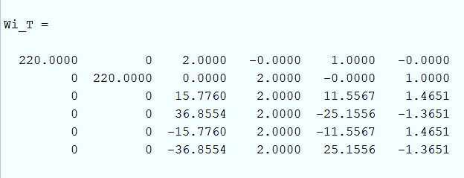

Figure

If we do not want to excite the first frequency, given that the fourth and sixth values of the matrix are zero and not zero in the other lines, we can define the initial conditions as follows:

|  |
| --- |
|  |

In this case we have:

Equation 30

If we do not want to excite the second frequency, given that the third and fifth values of the second row of matrix are zero and not zero in the other lines, we can define the initial conditions as follows:

|  |
| --- |
|  |

Equation 31

**10-**

In this section, we want to decompose the system using the Kalman method and obtain controllable or visible subsystems.

The system is controllable but unobservable because the rank of the visibility matrix is 4, so we select 4 independent rows of the matrix observability:

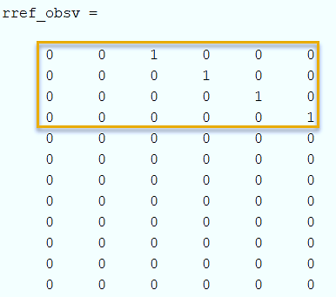

Figure -rref(observability)

We add two more independent rows to get the base vector:

|  |
| --- |
|  |

Figure -The added rows

So the unique conversion matrix is :

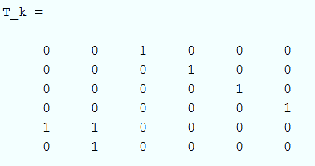

Figure - Unique Conversion Matrix

The Kalman decompose is as below:

fghhbnm


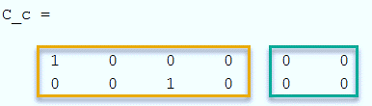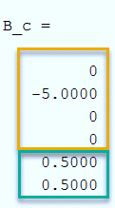

**11 –**

In the last part, we want to check whether the realization of the state space is minimal or not and also to determine the of the system. To do this, we use the following code:

%% Part 11 : Minimal Realization

sys = ss(A,B,C,D)

sysr = ss(A_bar_o,B_bar_o,C_bar_o,D)

%sysr = minreal(sys)

if(rank(sys.A) == rank(sysr.A))

disp("The Realization is minimal")

else

disp("The Realization is not minimal")

end;

eig_o = eig(A_bar_o) % observable poles

eig_o_bar = eig(A_bar_o_bar) % unobservable poles

The minimum realization will be as follows:

Figure 9 : Comparison between the minimal system and the main system

|  |
| --- |
|  |

To determine the stabilizability and detectablity of the system, it is necessary to determine the controllable and visible poles.

According to the figure 10:

Invisible poles = 0,0

Visible poles = -18.4277, -7.8880, 7.8880, 18.4277 -*All poles are controllable*-

Due to the fact that the system is controllable, it is also stabilizable, but due to the existence of zero conjugate states which are invisible, the system is detectable.

**Phase 2**

**1 –** Minimal Realizations  
**SISO Systems**  
To get some feel for how realizations relate to transfer functions, consider a SISO system in controller canonical form:

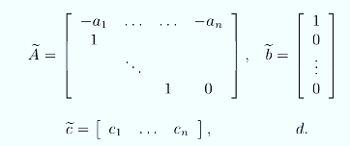

(You should draw yourself a block diagram of this, using delays, adders, gains.) Now verify that its transfer function is:



We can argue quite easily that there is a realization of order< n for this H(z) iff the numerator and denominator polynomials and respectively, have a common factor that cancels out. (If there is such a factor, we can get a controller canonical <n , by inspection. Conversely, if there is a realization of order <n, then its transfer function will have denominator degree<n which implies that c(z),a(z) above have a common factor)

Now, a common factor (z-λ) between c(z) and a(z) exists if:

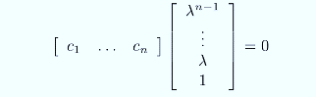

for some λ that is a root of a(z )= [zI-Ẫ] i.e. for some λ that is an eigenvalue of Ẫ. Verifying that the column vector in the preceding equation is the corresponding eigenvector of Ẫ, from the modal test for observability that the condition in this equation is precisely equivalent to unobservability We are now in a position to prove the following result:

we recognize:

“A state-space realization of a SISO transfer function H (z) is minimal iff it is reachable and observable.”   
Proof.  
If the realization is not ro, then the ro part of its Kalman decomposition will yield a lower-order realization, which means the original realization was not minimal. Conversely, if the realization is reachable and observable, it can be transformed to controller canonical form, and the denominator [zI-Ẫ] of H (z ) will have no cancellations with the numerator, so the realization will be minimal.

**MIMO Systems**

The preceding theorem also holds for the MIMO case, as we shall demonstrate now. Our proof of the MIMO result will use a different route than what was used in the SISO case, because a pro of analogous to the SISO one would rely on machinery | such as matrix fraction descriptions of rational matrices which we shall not be developing for the MIMO case in this course. There is nevertheless some value in seeing the SISO arguments above, because they provide additional insight into what is going:

“A realization is minimal iff it is reachable and observable”

Proof: If a realization is not reachable or not observable, we can use the Kalman decomposition to extract its r o part, and thereby obtain a realization of smaller order.  
  
For the converse, suppose (A,B,C,D ) is a reachable, observable realization of order n, but is not minimal. Then there is a minimal realizationof order (and necessarily reachable and observable, from the first part of our proof). Now

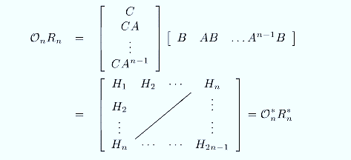

The reachability and observability of (A,B,C,D ) ensures that rank(on Rn ) =n (as can be verified using Sylvester's inequality) while rank  
but then the matrix is impossible. Hence there is no realization of order less than n if there is a reachable and observable one of order n. The following theorem shows that minimal realizations are tightly connected: in fact there is in effect only one minimal realization of a given H (z), up to a similarity transformation (or change of coordinates)  
Based on the information that has been given since our system is already controllable and not observable we only need to find the observable sub-system which has been already accomplished in phase 1 and here is the result:

Initially our system was controllable but not observable so we have:

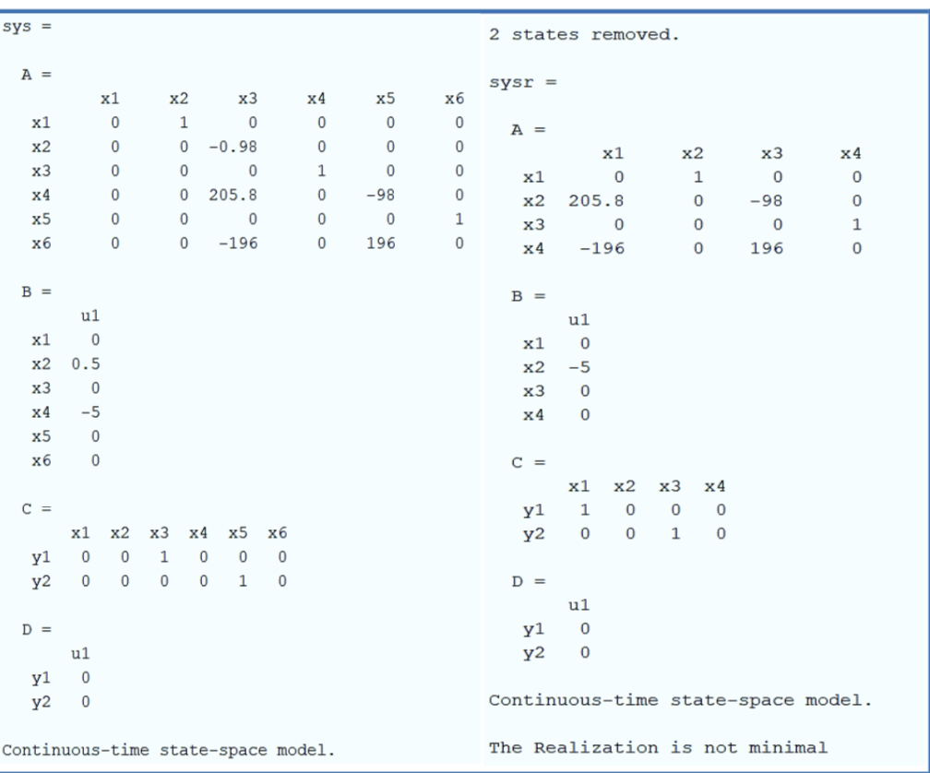

And with kalman separation we have:

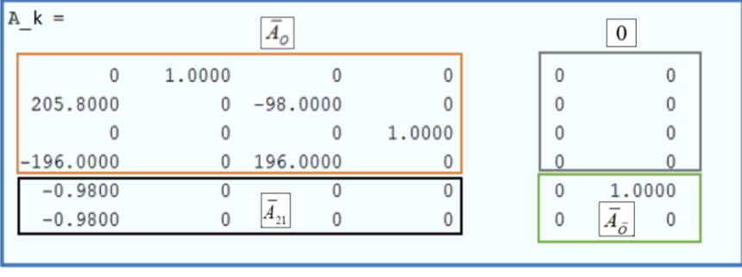 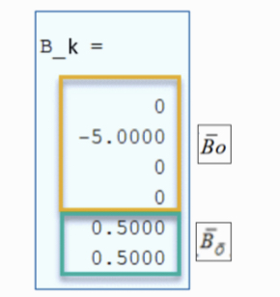

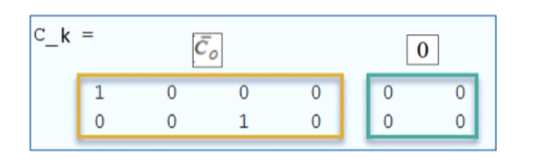

So by dividing the observable part now we have the minimal realization

**2-**

Rise time

In [electronics](https://en.wikipedia.org/wiki/Electronics), when describing a [voltage](https://en.wikipedia.org/wiki/Voltage) or [current](https://en.wikipedia.org/wiki/Current_(electricity)) [step function](https://en.wikipedia.org/wiki/Step_function), rise time is the time taken by a [signal](https://en.wikipedia.org/wiki/Signal_(electrical_engineering)) to change from a specified low value to a specified high value. These values may be expressed as [ratios](https://en.wikipedia.org/wiki/Ratio) or, equivalently, as [percentages](https://en.wikipedia.org/wiki/Percentage) with respect to a given reference value. In [analog electronics](https://en.wikipedia.org/wiki/Analog_electronics) and [digital electronics](https://en.wikipedia.org/wiki/Digital_electronics), these percentages are commonly the 10% and 90% (or equivalently 0.1 and 0.9) of the output step height: however, other values are commonly used. For applications in control theory, according to [Levine (1996](https://en.wikipedia.org/wiki/Rise_time#CITEREFLevine1996), p. 158), rise time is defined as "the time required for the response to rise from x% to y% of its final value", with 0% to 100% rise time common for [underdamped](https://en.wikipedia.org/wiki/Underdamped) second order systems, 5% to 95% for [critically damped](https://en.wikipedia.org/wiki/Critically_damped) and 10% to 90% for [overdamped](https://en.wikipedia.org/wiki/Overdamped) ones. According to [Orwiler (1969](https://en.wikipedia.org/wiki/Rise_time#CITEREFOrwiler1969), p. 22), the term "rise time" applies to either positive or negative [step response](https://en.wikipedia.org/wiki/Step_response), even if a displayed negative excursion is popularly termed [fall time](https://en.wikipedia.org/wiki/Fall_time):



overshoot

In [signal processing](https://en.wikipedia.org/wiki/Signal_processing), [control theory](https://en.wikipedia.org/wiki/Control_theory), [electronics](https://en.wikipedia.org/wiki/Electronics), and [mathematics](https://en.wikipedia.org/wiki/Mathematics), overshoot is the occurrence of a signal or function exceeding its target. Undershoot is the same phenomenon in the opposite direction. It arises especially in the [step response](https://en.wikipedia.org/wiki/Step_response) of [bandlimited](https://en.wikipedia.org/wiki/Bandlimited) systems such as [low-pass filters](https://en.wikipedia.org/wiki/Low-pass_filter). It is often followed by [ringing](https://en.wikipedia.org/wiki/Ringing_(signal)), and at times conflated with the latter.

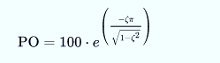

In order to make our system a desirable yet function able system we have designed our system with 20%overshoot and 4 second rise time with considering this two condition only we can obtain 2 poles as it’s the desirable root for a second order system so in order to keep up with our original system we take the other 4 poles very far to empower our desirable poles and make them dominant.so we have:

= 0.45

Main poles : {-1+2i,-1-2i}

Added poles :{-10,-12,-15,-20}

And with this we began designing the feedback controller.

First we take F matrix such that our eigenvalues will be the desired pole then we will obtain matrix in a way which leads to have this couple (F, ) will be observable (make the observability matrix in matlab ) then take lyapunov into consideration and from this equation we will be able to get matrix F and then from this and now we have the gain for our feedback.

The result will be:

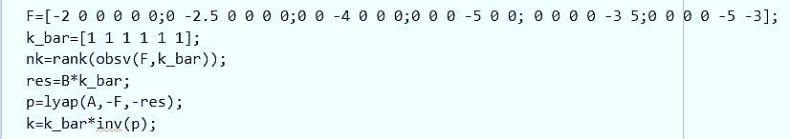

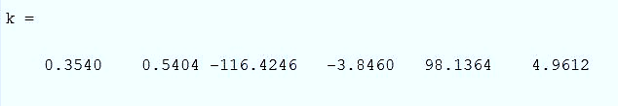

**3-**

The state feedback of the nonlinear and linear system are in form below.

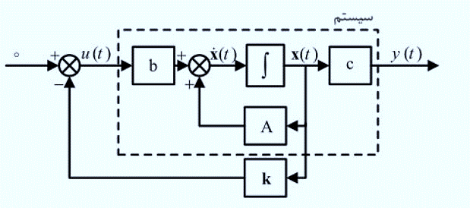

**Nonlinear**

First, we designed the nonlinear system in Simulink,

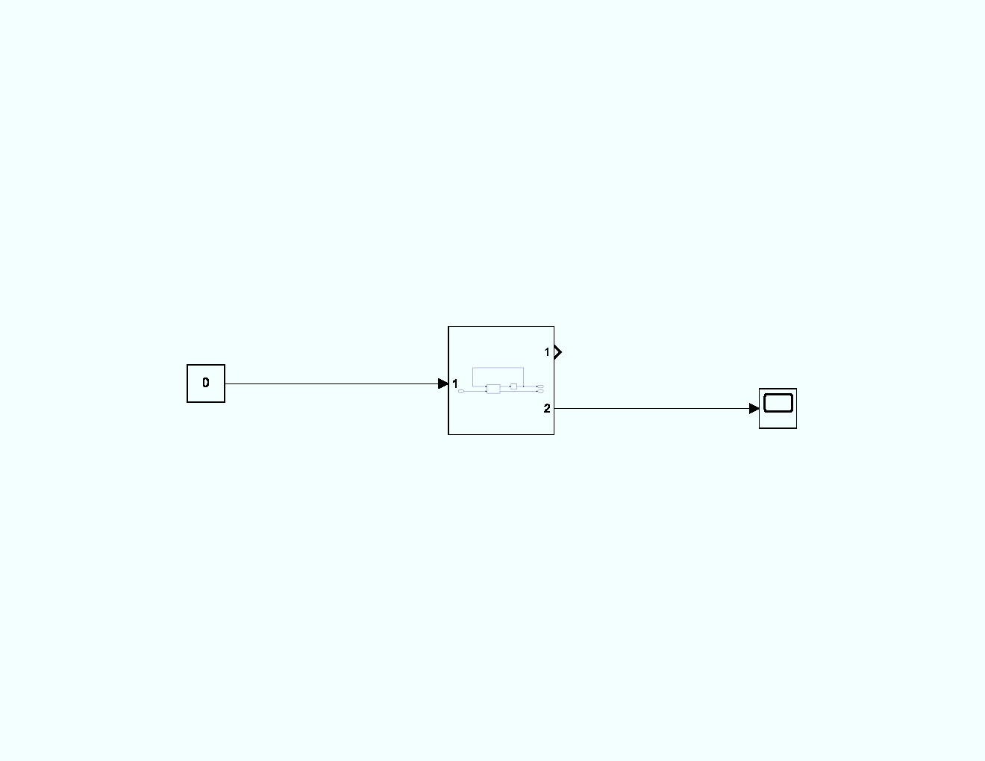

The subsystem is:

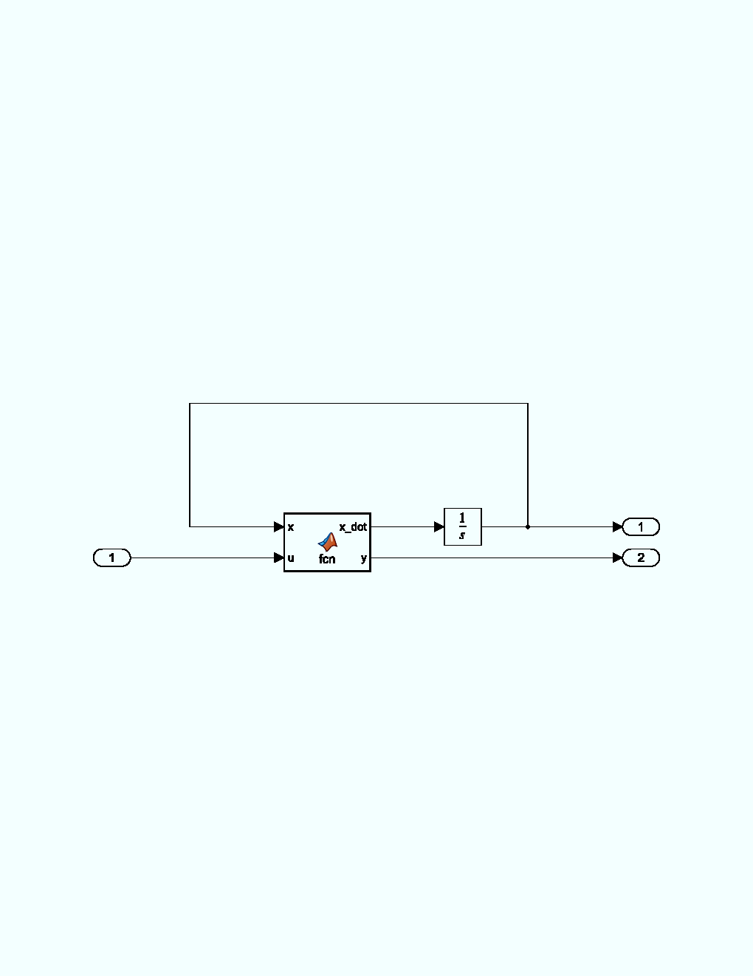

The MATLAB function calculate the and y.

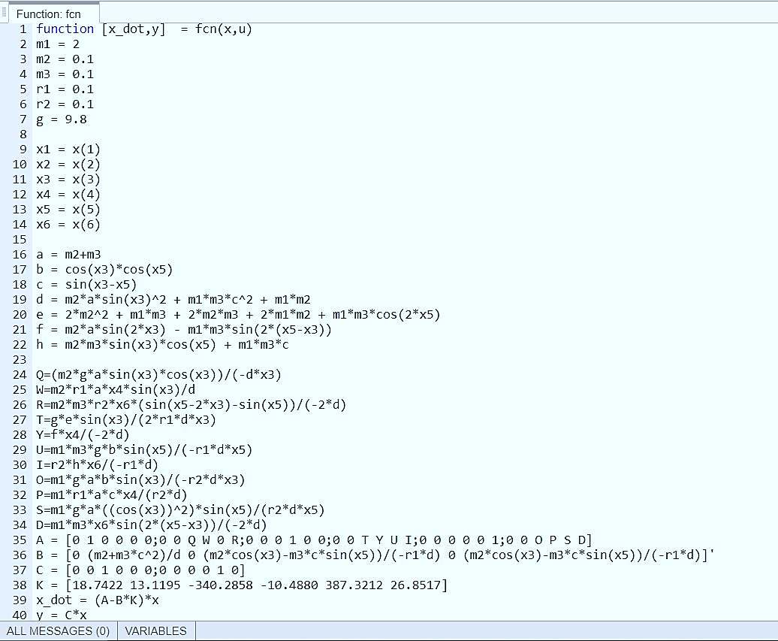

The output of the Simulink is:

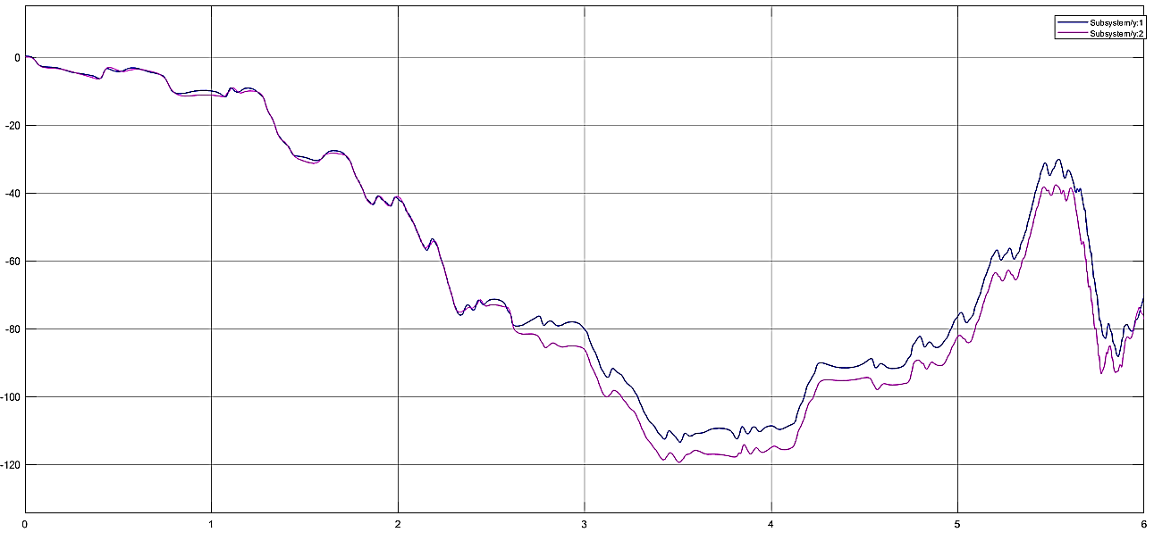

As we can see the response is unstable.

**linear**

Second, we design the linear system in Simulink:

A, B and C had been defined in the previous section. The only parameter left is K1.

Our system, since rank(C(A,B))=6 and rank(O(A,C))=4 ,is controllable but not observable.

The unit feedback controller is simulated in MATLAB as shown below.

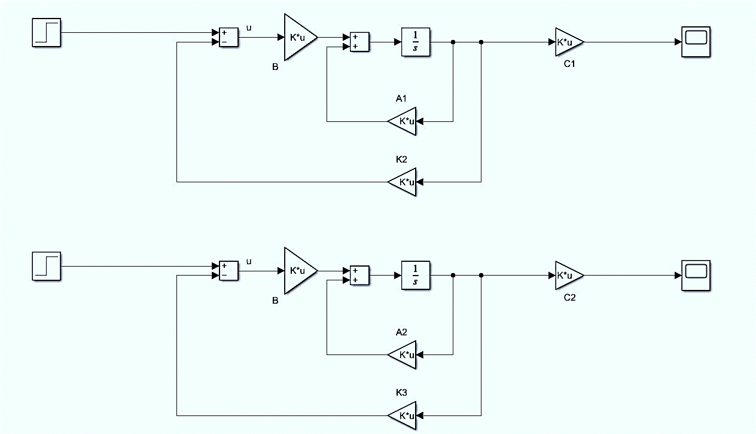

The response of the simulated system in MATLAB environment is as follows.

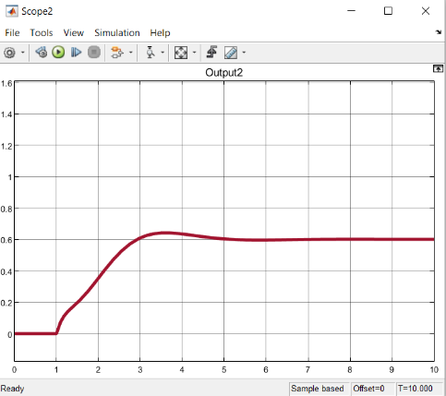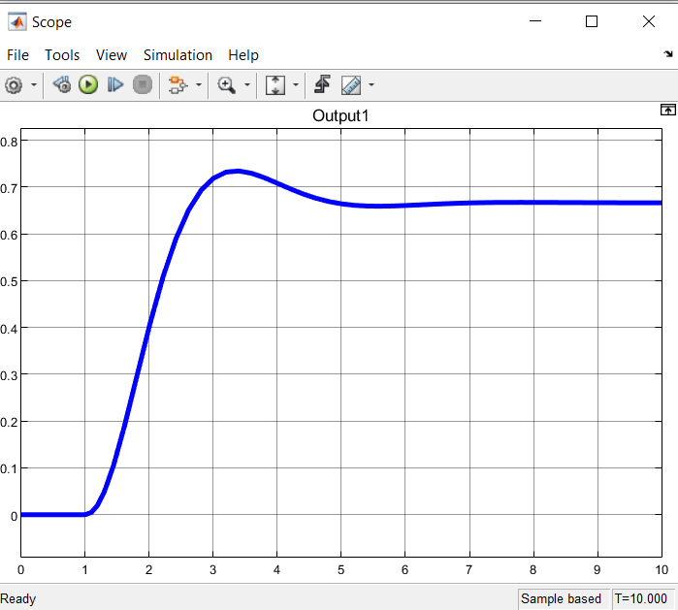

**5-**

The step signal is selected as reference signal.

The following is the Simulink and the results of each of the outputs.

Simulink of Static compensator:

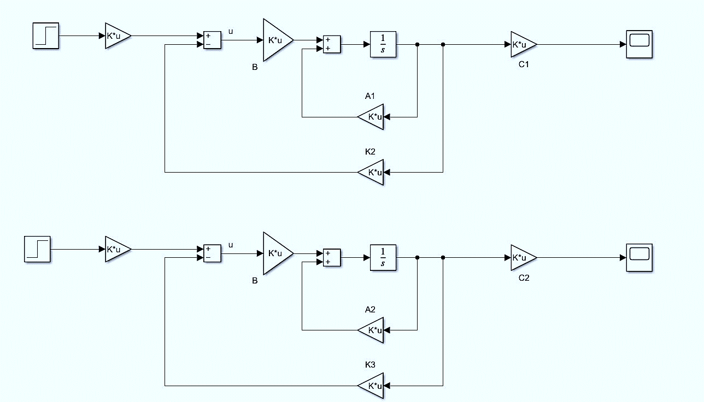

Output of Static compensator: 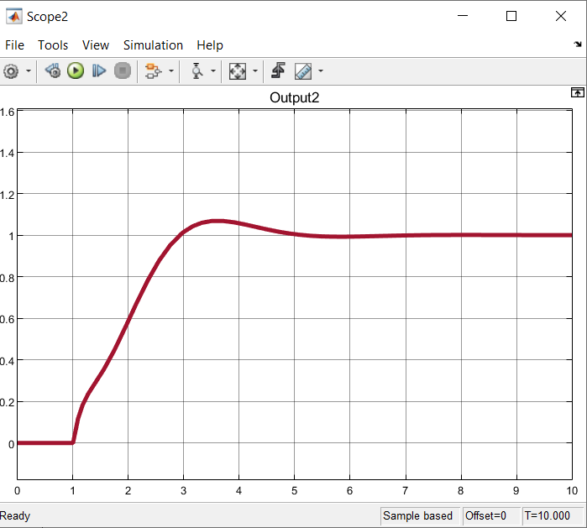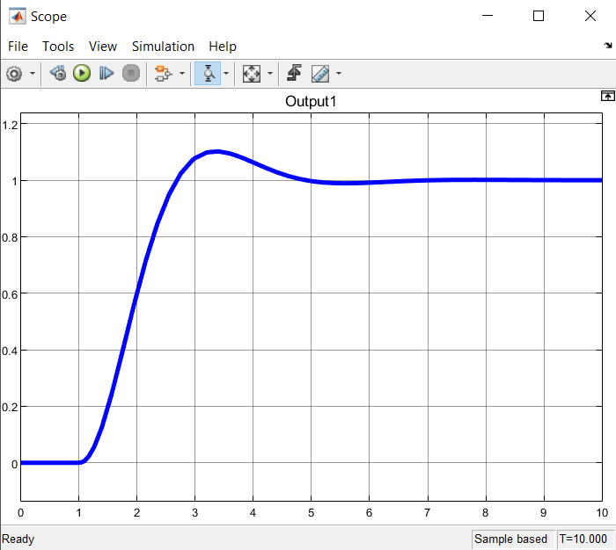

Simulink and output using integral controller:

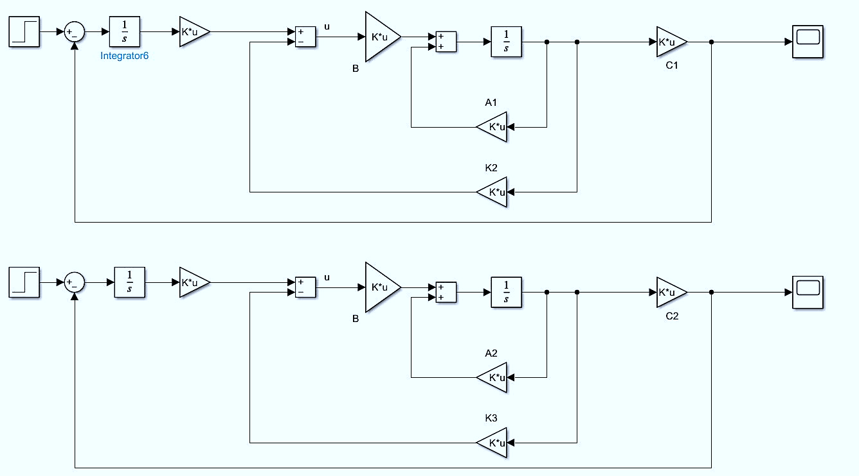

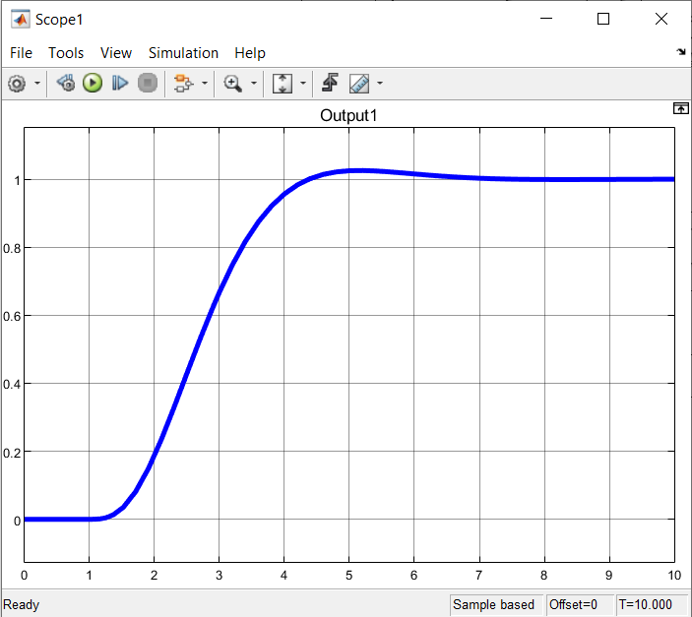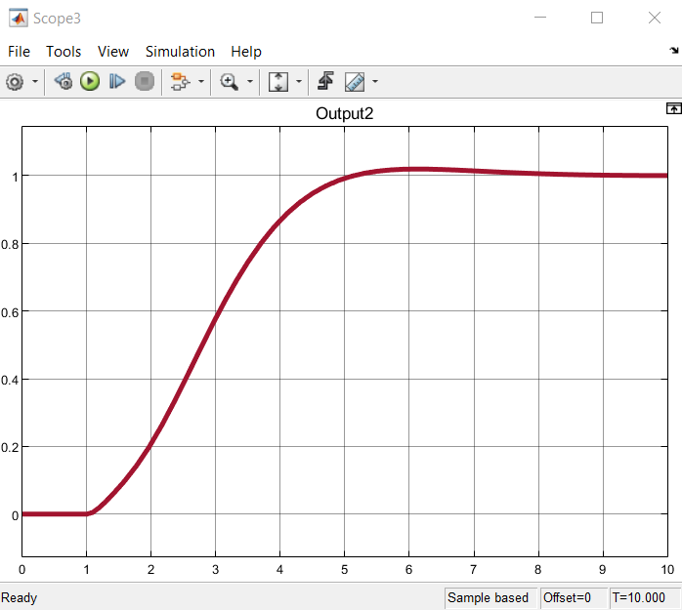

Comparison of dynamic and static controllers in the presence of disturbance:

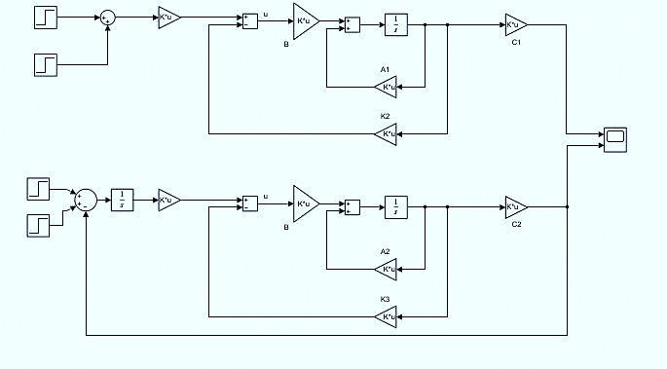

Output 1:

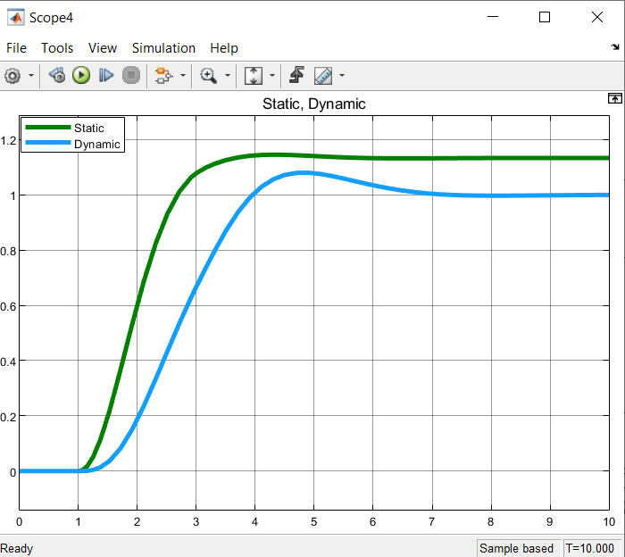

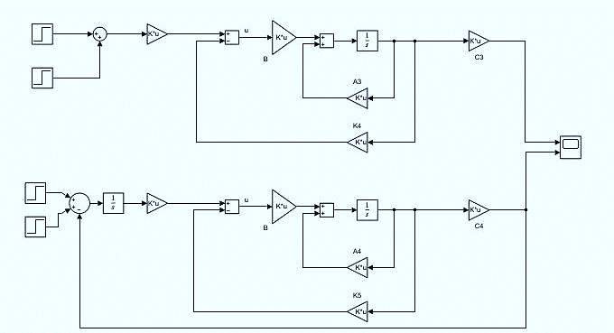

Output 2:

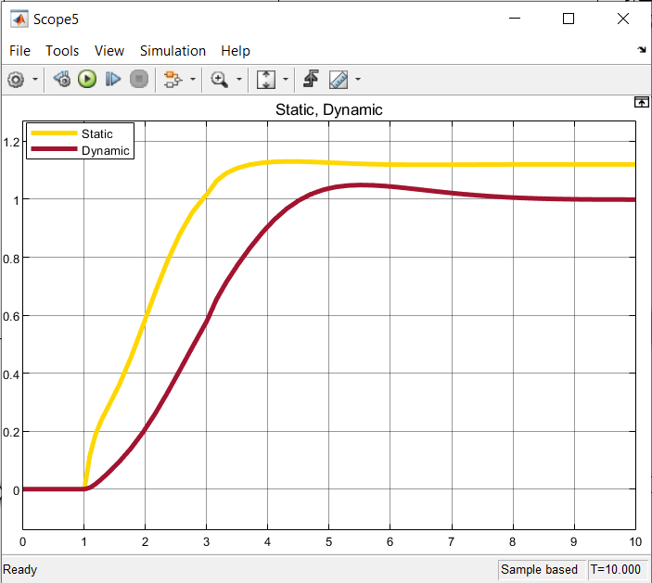

You can see that in both cases, by adding the disturbance, the integral controller performed better than static.

**phase 3**

**1-**

Full order observer  
in the pole-placement approach to the design of control systems, we assumed that all state variables are available for feedback

In practice, however, not all state variables are available for feedback, for instance, if the component is in an inaccessible location, or the sensors are expensive.  
Estimation of unmeasurable state variables is commonly called observation.  
 A device (or a computer program) that estimates or observes the state variables is called a state estimator, state observer, or simply an observer.  
 There are two types of state observers  
– Full Order State Observer  
 If the state observer observes all state variables of the system, regardless of whether some state variables are available for direct measurement, it is called a full-order state observer.  
– Reduced Order State Observer  
 If the state observer observes only those state variables which are not available for direct measurement, it is called a reduced-order state observer.

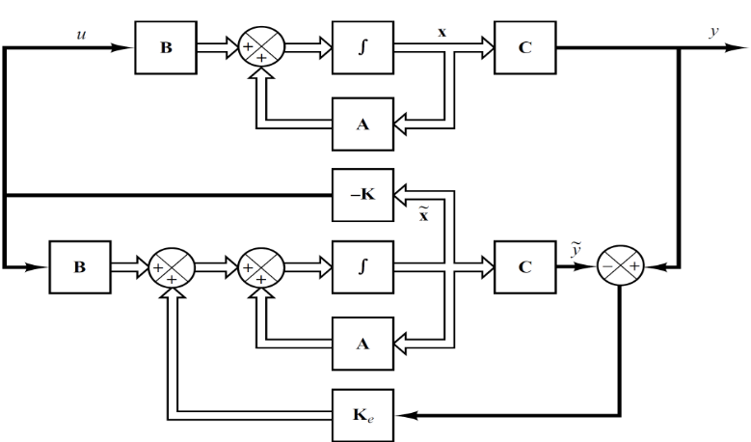

A state observer estimates the state variables based on the measurements of the output and control variables. Here the concept of observability plays an important role.  
 State observers can be designed if and only if the observability condition is satisfied Consider the plant defined by

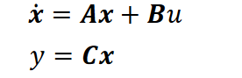

The mathematical model of the observer is basically the same as that of the plant, except that we include an additional term that includes the estimation error to compensate for inaccuracies in matrices A and B and the lack of the initial error  
The estimation error or observation error is the difference between the measured output and the estimated output.   
The initial error is the difference between the initial state and the initial estimated state.  
Thus we define the mathematical model of observer to be

  
Where is estimated state vector, is estimated output and 𝑲𝒆 is observer gain matrix  
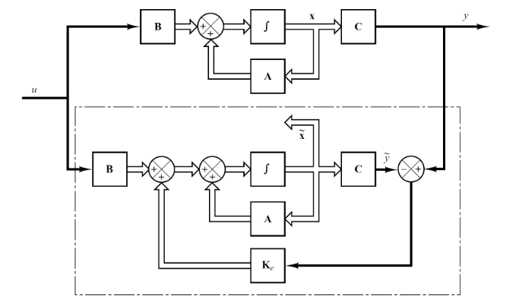

The order of the state observer that will be discussed here is the same as that of the plant.  
Consider the plant define by following equations

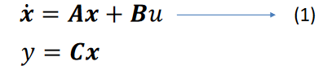

Equation of state observer is given as



To obtain the observer error equation, let us subtract Equation (2) from Equation (1):

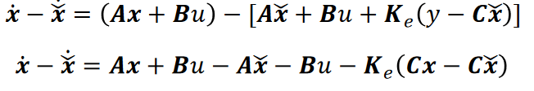

Simplifications in above equation yields



Define the difference between 𝒙 and as the error vector e.



Equation (3) can now be written as

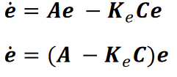

From above equation we see that the dynamic behavior of the error vector is determined by the eigenvalues of matrix A-KeC.  
If matrix A-KeC is a stable matrix, the error vector will converge to zero for any initial error vector e(0).  
That is,) will converge to 𝒙(𝒕) regardless of the values of x(0).  
 And if the eigenvalues of matrix A-KeC are chosen in such a way that the dynamic behavior of the error vector is asymptotically stable and is adequately fast, then any error vector will tend to zero (the origin) with an adequate speed

if the plant is completely observable, then it can be proved that it is possible to choose matrix Ke such that A-KeC has arbitrarily desired eigenvalues.  
 That is, the observer gain matrix Ke can be determined to yield the desired matrix A-KeC  
Duality Property  
Consider the system defined by

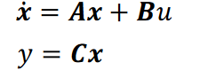

In designing the full-order state observer, we may solve the dual problem, that is, solve the pole-placement problem for the dual system.

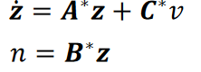

• Assuming the control signal 𝑣 to be



If the dual system is completely state controllable, then the state feedback gain matrix K can be determined such that matrix A*-C*K will yield a set of the desired eigenvalues.  
  
  
• If 𝜇1 , 𝜇2 ,..., 𝜇𝑛 , are the desired eigenvalues of the state observer matrix, then by taking the same 𝜇𝑖′𝑠 as the desired eigenvalues of the state-feedback gain matrix of the dual system, we obtain  
  
   
  
  
• Noting that the eigenvalues of A*-C*K and those of A-K*C are the same, we have  
 

Comparing the characteristic polynomial |𝑠𝐼 − (𝑨 – 𝑲*𝑪 )| and the characteristic polynomial for the observer system |𝑠𝐼 − (𝑨 − 𝑲𝑒𝑪 )| , we find that Ke and K* are related by

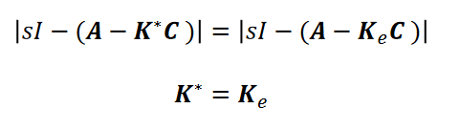  
  
Thus, using the matrix K determined by the pole- placement approach in the dual system, the observer gain matrix Ke for the original system can be determined by using the relationship Ke=K*  
with this in mind we shall began designing our own system consider A and C matrix and now in this way we need to use the transpose of matrix A as a new A and the transpose of matrix C as the new B and continue the steps of designing gain for feedback with these consideration:

First we define matrix F with different eigenvalues from A and we put our desired poles value in it the dimension will be 6*6 and after that we will define Kbar in a way that the couple of Kbar and F will be observable and the we will solve lyapunov and from that we will be able to obtain matrix P. with P and kbar we can now obtain K and after that with duality rule we will have L (gain) by transposing K.

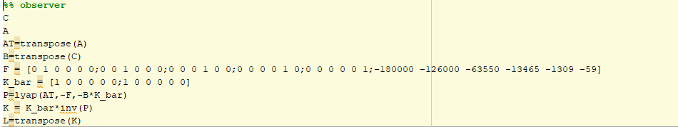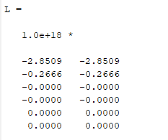  
  
sometimes our state can be measure directly so we don’t need to spend some extra cost to predict them in this case we use reduced observer

First we need to obtain the rank of the c .after that from n-q (q=rank(c), n= our system rank) we can have our new system dimension. Now our F matrix will be in a reduced form and in our case will be 4*4 with the eigenvalues totally different from A and then we make L matrix in a way which our L and F matrix will be controllable and from solving lyapunov rule we will have T but it wont end here after that we need to ccontinue and make [C;T] matrix and if it was singular we need to change our L. in our first attempt it’s determinant went zero so we changed it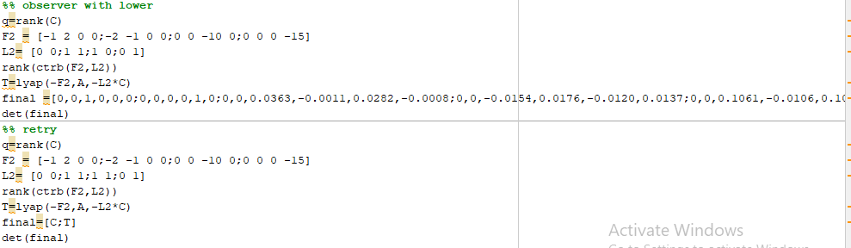

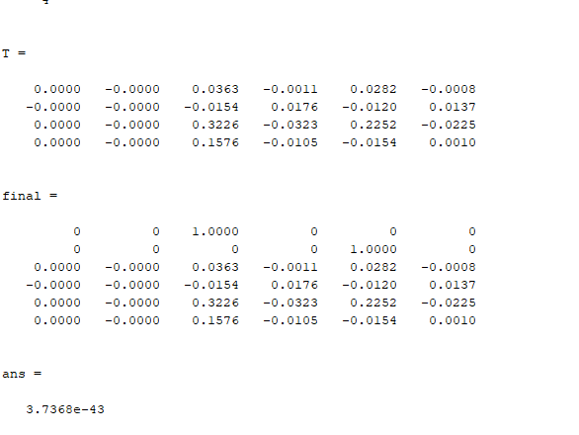

**2-**

In the design of Part 5 in the second phase of the project (static and dynamic compensator design), we used the estimated modes of full-order observer and reduced-order observer, and compared our results as follows.

static compensator design using full-order observer :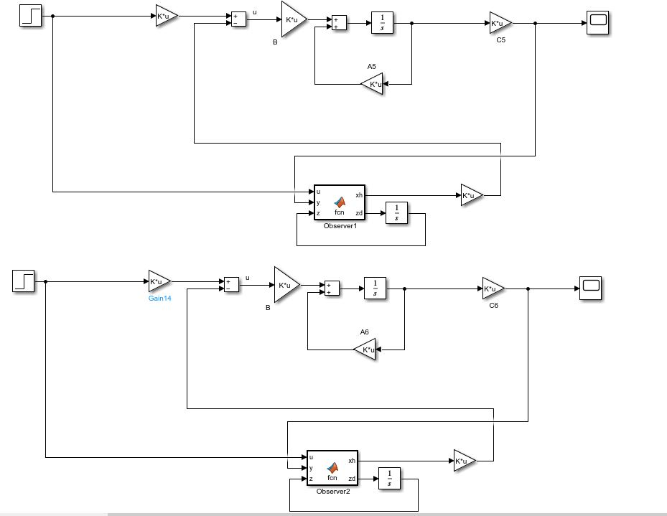

Output:

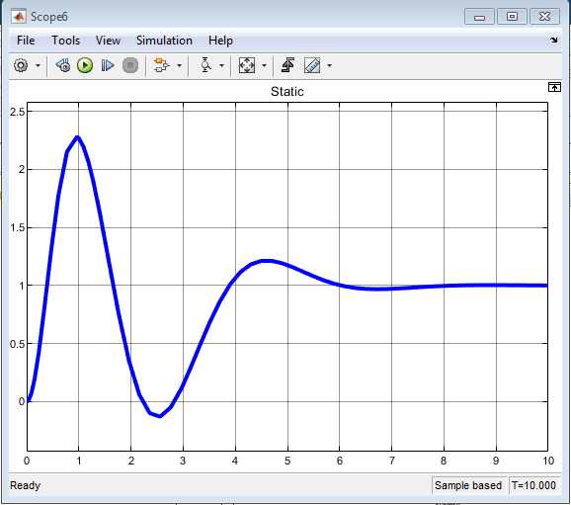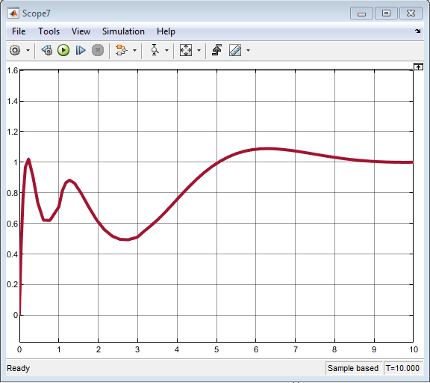

static compensator design using reduced-order observer:

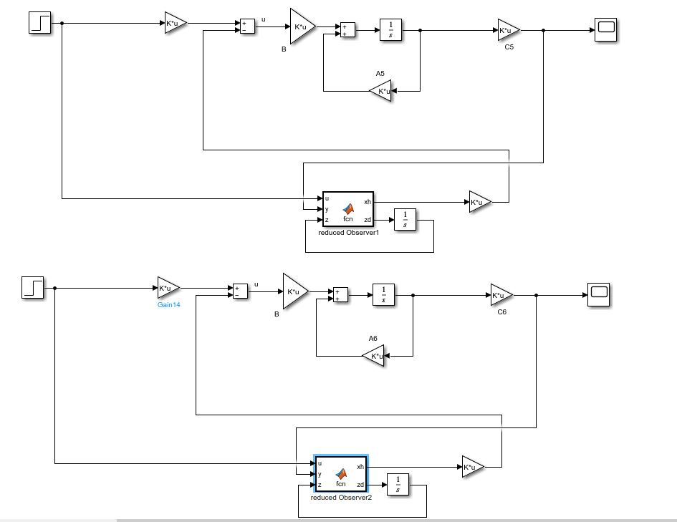

Output:

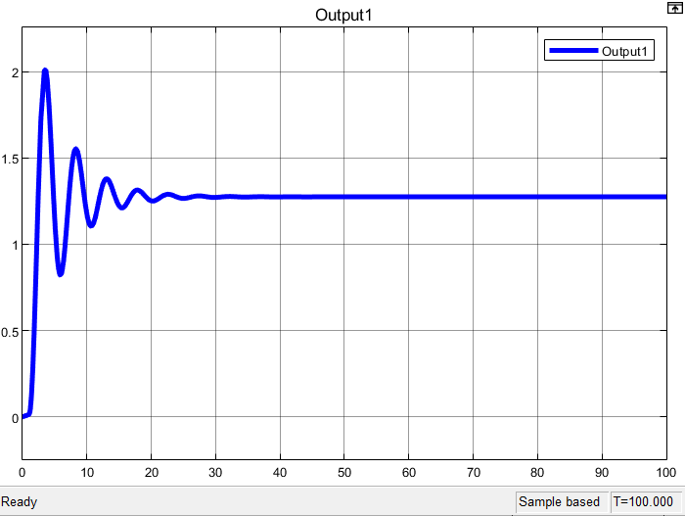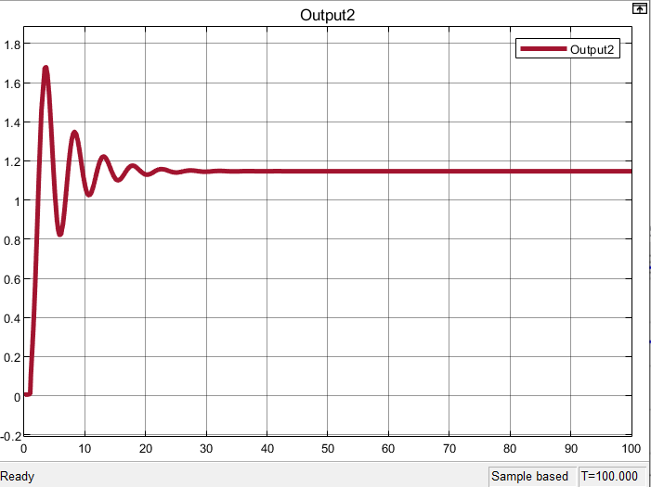

dynamic compensator design using full-order observer:

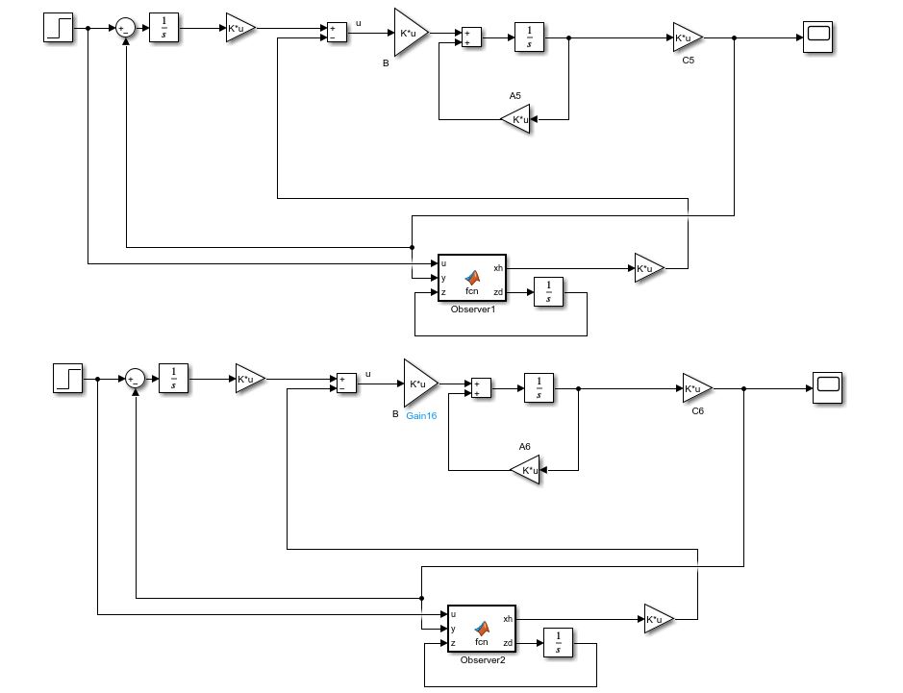

Output:

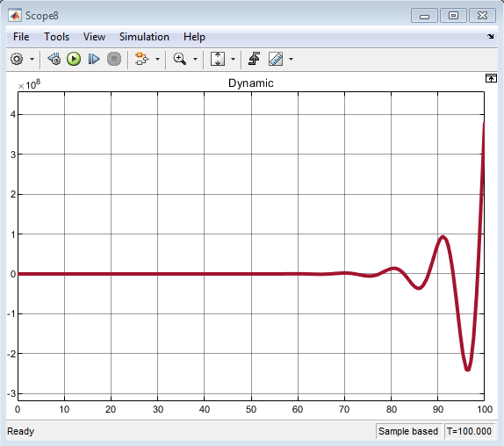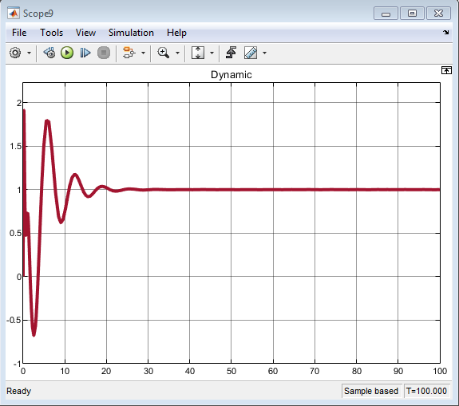

The output 1 is unstable as the above.

dynamic compensator design using reduced-order observer:

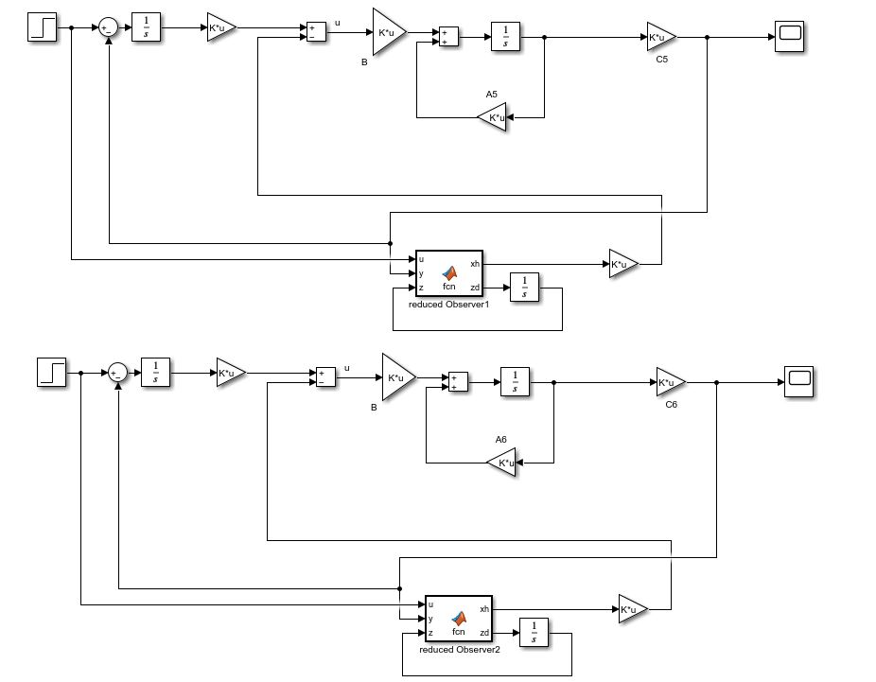

Output:

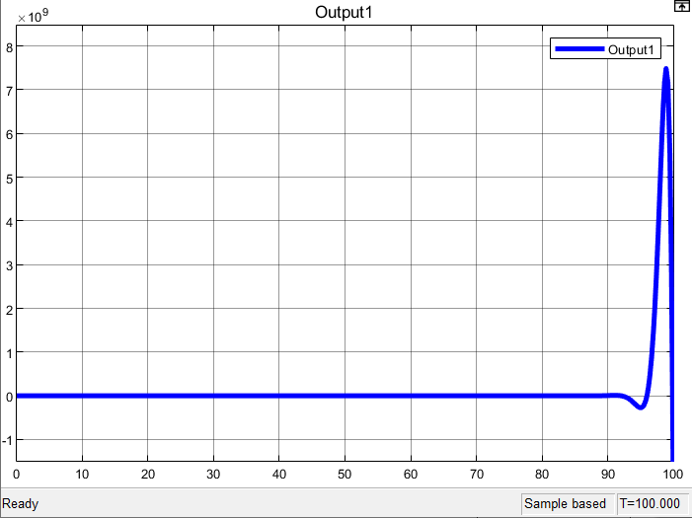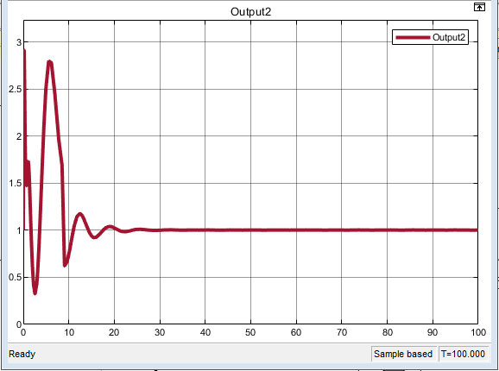

**Sources:**

1. <https://www.myphysicslab.com/pendulum/inverted-double-pendulum-en.html>
2. file:///C:/Users/admin/AppData/Local/Temp/351_27435_EE412_2019_1__2_1_0%206%20EE412%20Lec6%20Full%20order%20state%20observer_design.pdf
3. https://www.sciencedirect.com/topics/engineering/double-inverted-pendulum
4. <https://www.math.arizona.edu/~gabitov/teaching/201/math_485/Final_Reports/Inverted_Pendulum_Final_Report.pdf>
5. <https://www.quora.com/How-is-this-equation-for-an-inverted-pendulum-derived>
6. <https://www.quanser.com/products/linear-double-inverted-pendulum/>
7. -----------Xuetal.Chapterrev4.pdf